

CLIENT: | Thelen CDJR | PHONE #:
SPOT: | THEL-CD-T210401 April Truck Month | FAX # :
LENGTH: | :30 | SALES REP: | Larry H.
DATE: | 4/5/2021 | PRODUCER | A. Dennis

GRAPHICS | Video | AUDIO
Thelen Chrysler Logo  Euclid Ave. - Bay City  www.thelenchryslerjeepdodge.com  (Chrysler, Dodge, Jeep, Ram Logos)  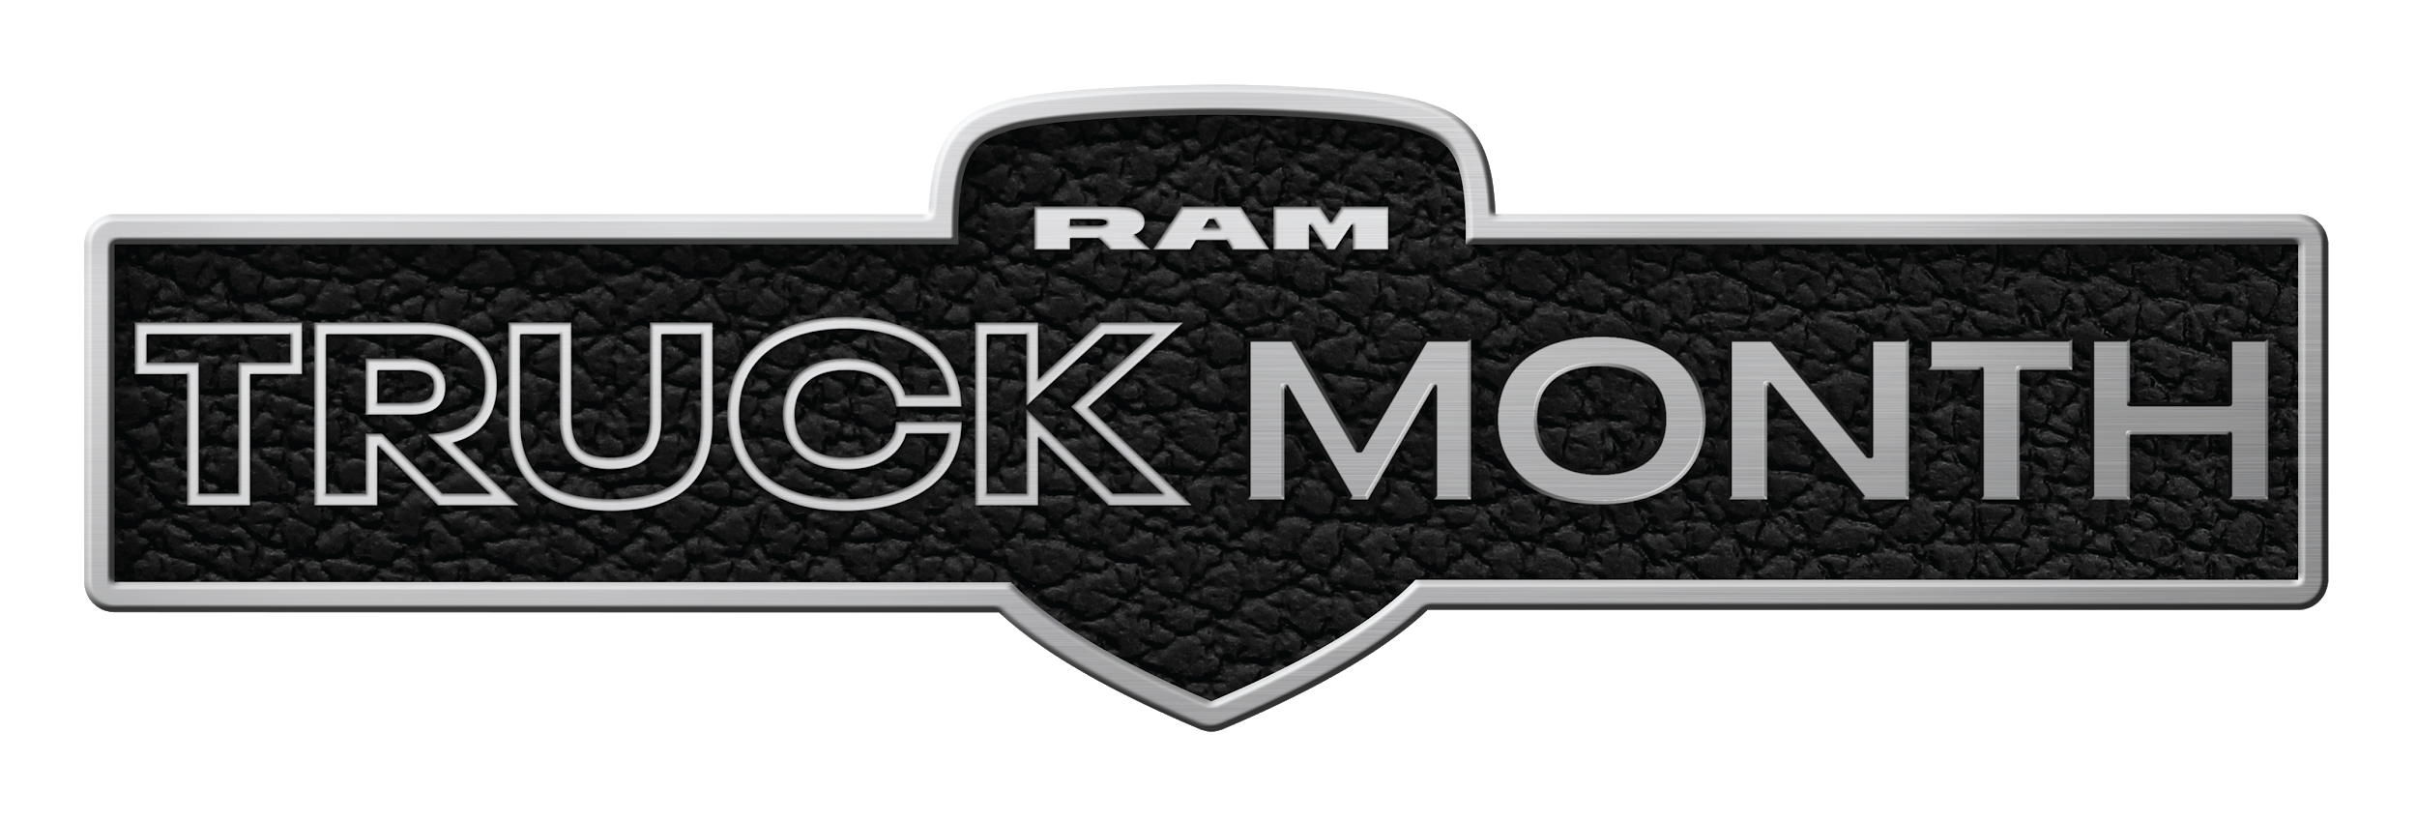  2021 Ram 1500 Big Horn Crew Cab  Lease From Just $349/mo  Lease for 36 months, 10,000 miles per year with approved credit. $3,012 down or trade equity due at signing. Tax extra. Must qualify for all available rebates and incentives. Picture may not represent the actual vehicle. Optional equipment shown not included. See Thelen Chrysler for details. Ends April 30th, 2021.  2021 Jeep Renegade Limited 4x4  Lease From Just $219/mo  0% APR for 84 Months  0% APR for 84 months equals $11.90 per $1,000 financed, regardless of down payment, for well qualified buyers with approved credit and financing through Chrysler Capital. Not all customers will qualify. Lease for 36 months, 10,000 miles per year with approved credit. $3,665 down or trade equity due at signing. Tax extra. Must qualify for all available rebates and incentives. Picture may not represent the actual vehicle. See Thelen Chrysler for details. See Thelen Chrysler for details. Ends April 30th, 2021.  Thelen Chrysler Logo  Euclid Ave. - Bay City  www.thelenchryslerjeepdodge.com  (Chrysler, Dodge, Jeep, Ram Logos) | GFX: 2021 Ram Truck Month (logo)  GFX: 2021 Ram 1500 Big Horn Crew Cab  GFX: 2021 Jeep Renegade Limited | Announcer: (:30)  Get MORE savings at Thelen Chrysler Dodge Jeep Ram in Bay City!  It’s Ram Truck Month! And Thelen Chrysler has deals that can’t be beat...  Because it’s the right thing to do!  This month, save BIG on a new Ram 1500 Big Horn! Now from just $349 a month!  Drive a new Jeep Renegade from just $219 a month! Or choose 0% APR for 84 months!  Now at Thelen Chrysler Dodge Jeep Ram! Euclid avenue, Bay City!  Getting you more for your money... because it’s the right thing to do!

